
Southern Luzon State University
COLLEGE OF ENGINEERING
Computer Engineering Department
Lucban, Quezon

CPE24L – Embedded Systems Assignment

Submitted by:
ESQUILLO, Jay Anthony L.
MAÑAGO, John Oshrick S.
PADUADA, Dave Jhared G.

Engr. Jose Yulo Manzanero
INSTRUCTOR
Fritzing Schematic
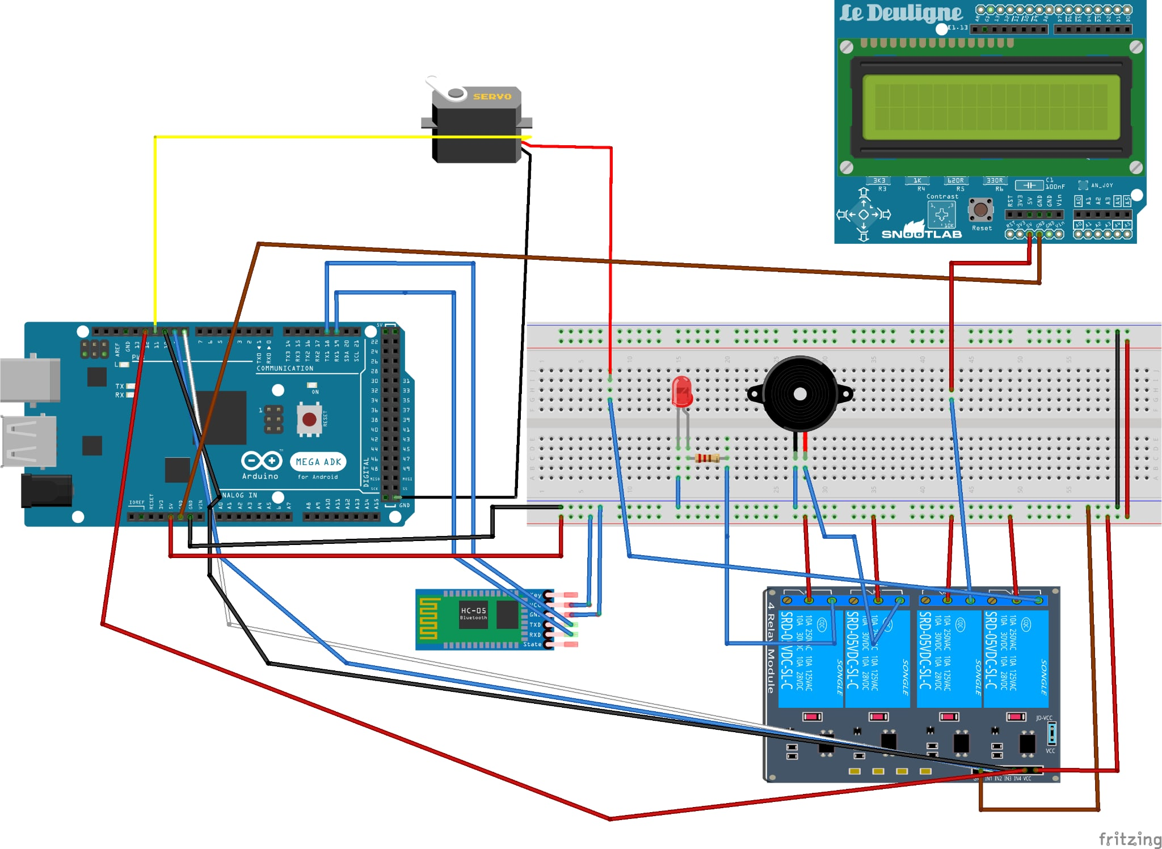
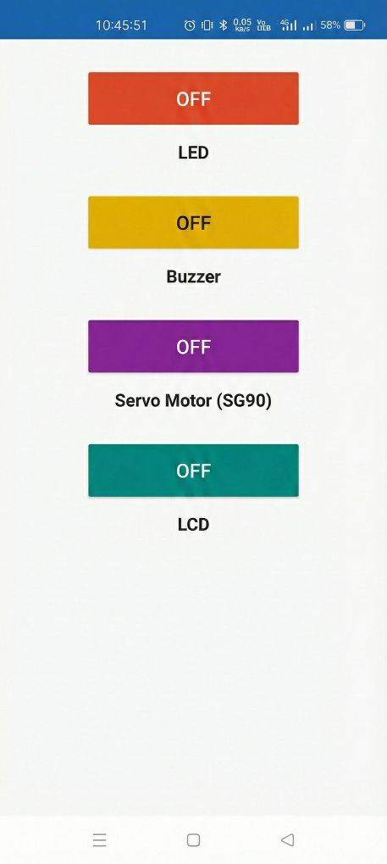
App Screenshot

App Code
package com.example.rccar
import android.annotation.SuppressLint
import android.bluetooth.BluetoothAdapter
import android.bluetooth.BluetoothDevice
import android.bluetooth.BluetoothManager
import android.bluetooth.BluetoothSocket
import android.content.Context
import android.os.Handler
import android.os.Looper
import android.util.Log
import java.io.IOException
import java.io.OutputStream
import java.util.UUID
object BluetoothService {
private const val TAG = "BluetoothService"
private val MY_UUID: UUID = UUID.fromString("00001101-0000-1000-8000-00805F9B34FB") // Standard SerialPortService ID
// Command constants (Arduino expects single character commands)
const val CMD_LED_ON = "1"
const val CMD_LED_OFF = "2"
const val CMD_BUZZER_ON = "3"
const val CMD_BUZZER_OFF = "4"
const val CMD_LCD_ON = "5"
const val CMD_LCD_OFF = "6"
const val CMD_SERVO_ON = "7"
const val CMD_SERVO_OFF = "8"
var bluetoothAdapter: BluetoothAdapter? = null
private var bluetoothSocket: BluetoothSocket? = null
private var outputStream: OutputStream? = null
var isConnected = false
private set
fun init(context: Context) {
val bluetoothManager = context.getSystemService(Context.BLUETOOTH_SERVICE) as BluetoothManager
bluetoothAdapter = bluetoothManager.adapter
}
@SuppressLint("MissingPermission")
fun connect(device: BluetoothDevice, onResult: (Boolean) -> Unit) {
bluetoothAdapter?.cancelDiscovery()
Thread {
try {
bluetoothSocket = device.createRfcommSocketToServiceRecord(MY_UUID)
bluetoothSocket?.connect()
outputStream = bluetoothSocket?.outputStream
isConnected = true
Handler(Looper.getMainLooper()).post { onResult(true) }
} catch (e: IOException) {
Log.e(TAG, "Connection failed", e)
closeConnection()
Handler(Looper.getMainLooper()).post { onResult(false) }
}
}.start()
}
fun sendCommand(command: String) {
if (!isConnected || outputStream == null) {
Log.w(TAG, "sendCommand ignored; not connected. cmd=$command")
return
}
try {
// Send raw command; Arduino handles trimming/newlines if present
val payload = command.toByteArray()
outputStream?.write(payload)
outputStream?.flush()
Log.d(TAG, "Command sent: $command")
} catch (e: IOException) {
Log.e(TAG, "Error sending command", e)
closeConnection()
}
}
fun closeConnection() {
try {
outputStream?.close()
bluetoothSocket?.close()
isConnected = false
} catch (e: IOException) {
Log.e(TAG, "Error closing connection", e)
}
}
}

package com.example.rccar
import android.content.pm.ActivityInfo
import android.os.Bundle
import android.view.LayoutInflater
import android.view.View
import android.view.ViewGroup
import androidx.fragment.app.Fragment
import com.example.rccar.databinding.FragmentActivityBinding
class ActivityFragment : Fragment() {
private var _binding: FragmentActivityBinding? = null
private val binding get() = _binding!!
override fun onCreateView(
inflater: LayoutInflater, container: ViewGroup?,
savedInstanceState: Bundle?
): View {
_binding = FragmentActivityBinding.inflate(inflater, container, false)
return binding.root
}
override fun onViewCreated(view: View, savedInstanceState: Bundle?) {
super.onViewCreated(view, savedInstanceState)
binding.toggleLed.setOnCheckedChangeListener { _, isChecked ->
BluetoothService.sendCommand(if (isChecked) BluetoothService.CMD_LED_ON else BluetoothService.CMD_LED_OFF)
}
binding.toggleBuzzer.setOnCheckedChangeListener { _, isChecked ->
BluetoothService.sendCommand(if (isChecked) BluetoothService.CMD_BUZZER_ON else BluetoothService.CMD_BUZZER_OFF)
}
binding.toggleServo.setOnCheckedChangeListener { _, isChecked ->
BluetoothService.sendCommand(if (isChecked) BluetoothService.CMD_SERVO_ON else BluetoothService.CMD_SERVO_OFF)
}
binding.toggleLcd.setOnCheckedChangeListener { _, isChecked ->
BluetoothService.sendCommand(if (isChecked) BluetoothService.CMD_LCD_ON else BluetoothService.CMD_LCD_OFF)
}
}
override fun onDestroyView() {
super.onDestroyView()
requireActivity().requestedOrientation = ActivityInfo.SCREEN_ORIENTATION_UNSPECIFIED
_binding = null
}
}

Arduino Code
#include <Servo.h>
#include <LiquidCrystal_I2C.h>
#include <Wire.h>

// --- PIN DEFINITIONS ---
const int LED_RELAY_PIN = 8; // Relay CH1 - LED
const int BUZZER_RELAY_PIN = 9; // Relay CH2 - Buzzer
const int LCD_RELAY_PIN = 10; // Relay CH3 - LCD Power
const int SERVO_POWER_PIN = 12; // Relay CH4 - Servo Power
const int SERVO_SIGNAL_PIN = 11; // Servo Signal Pin

// --- GLOBAL OBJECTS ---
Servo myServo;
LiquidCrystal_I2C lcd(0x27, 16, 2);

// --- VARIABLES ---
char incomingByte = 0;

void setup() {
// Initialize serial ports
Serial.begin(9600);
Serial1.begin(9600);

// Initialize relay pins
pinMode(LED_RELAY_PIN, OUTPUT);
pinMode(BUZZER_RELAY_PIN, OUTPUT);
pinMode(LCD_RELAY_PIN, OUTPUT);
pinMode(SERVO_POWER_PIN, OUTPUT);

// Attach servo
myServo.attach(SERVO_SIGNAL_PIN);
myServo.write(0); // Initial servo angle

Serial.println("System Initialized. All Relays OFF.");
delay(1000);

// All relays OFF (HIGH = OFF)
digitalWrite(LED_RELAY_PIN, HIGH);
digitalWrite(BUZZER_RELAY_PIN, HIGH);
digitalWrite(LCD_RELAY_PIN, HIGH);
digitalWrite(SERVO_POWER_PIN, HIGH);
}

void loop() {
if (Serial1.available() > 0) {
incomingByte = Serial1.read();

Serial.print("Received Command: ");
Serial.println(incomingByte);

switch (incomingByte) {

// --- LED Control (Relay 1) ---
case '1':
digitalWrite(LED_RELAY_PIN, LOW);
Serial.println("-> LED ON");
break;

case '2':
digitalWrite(LED_RELAY_PIN, HIGH);
Serial.println("-> LED OFF");
break;

// --- Buzzer Control (Relay 2) ---
case '3':
digitalWrite(BUZZER_RELAY_PIN, LOW);
Serial.println("-> BUZZER ON");
break;

case '4':
digitalWrite(BUZZER_RELAY_PIN, HIGH);
Serial.println("-> BUZZER OFF");
break;

// --- LCD Power Control (Relay 3) ---
case '5':
digitalWrite(LCD_RELAY_PIN, LOW);
Serial.println("-> LCD POWER ON (Relay K3 Activated)");
// Initialize LCD
lcd.init();
lcd.backlight();
lcd.setCursor(0, 0);
lcd.print("Merry Christmas");
lcd.setCursor(0, 1);
lcd.print("System Active");
break;

case '6':
digitalWrite(LCD_RELAY_PIN, HIGH);
Serial.println("-> LCD POWER OFF (Relay K3 Deactivated)");
break;

// --- Servo Power + Movement (Relay 4) ---
case '7': // Servo ON
digitalWrite(SERVO_POWER_PIN, LOW);
myServo.write(90);
delay(1000);
Serial.println("-> Servo Power ON (K4 ON) & 90 deg command sent.");
break;

case '8': // Servo OFF
Serial.println("-> Servo Power OFF (K4 OFF)");
myServo.write(0);
delay(1000);
digitalWrite(SERVO_POWER_PIN, HIGH);
break;

// --- Unknown Command ---
default:
Serial.println("-> Unknown command.");
break;
}
}
}

